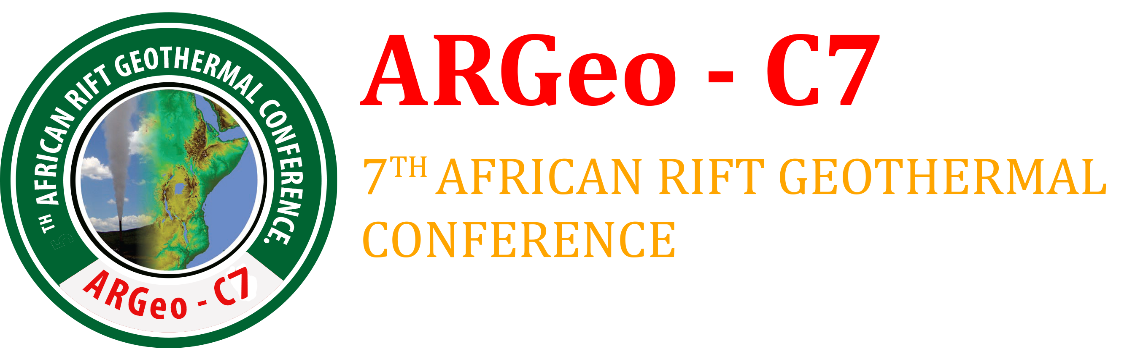

**Outline for writing the Country update Paper**

The following is the recommended outline for country update papers. The format should follow the earlier ARGEO conferences template sent as a separate file.

1. Paper Title: Geothermal Development in *(insert name of your Country)* – a Country Update
2. Abstract

* *Should contain Summary of the report*

1. Introduction

* *Introduction of your paper*

1. Status of Electricity Production (from all sources of energy)

* *Current total installed and effective capacity*
* *Modes of generation and their contributions*
* *Contribution from geothermal (if any) should be highlighted*
* *Medium Term and Long Term Power development plan and the role to be played by geothermal in the achievement of the plans*

1. Status of Geothermal Development in the country

* *Geological setting and map showing potential sites for geothermal development*
* *Results of surface exploration done*
* *Results of exploration, appraisal and production Drilling*
* *Results of well discharge tests and well out put*
* *Resource potential in the country*
* *Utilization (power production and direct use)*
  + *Provide a table with the following information – Power plant owner, plant location (field), plant type (binary, condensing, etc), manufacturer, year of commissioning, units, equipment rating, total plant capacity, plant capacity factor*
  + *Direct Use – where utilized and energy capacity if known*
  + *Power Plants planned for commissioning by 2020 (provide plant capacity and planned year of commissioning)*

1. Investment Opportunities

* *Investment opportunities for potential investors*
* *Incentives offered to developers*

1. Outlook and Conclusions

* *Conclusions and way forward*

1. References